**Delaware Military Heritage And Education Foundation / Delaware Military Museum**

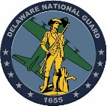





**National Guard**

**Chairman of the Board**



**Board of Directors**







**Vice Chairman of the Board**

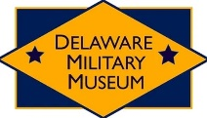







**Sub Committees**



**Curator**

**Executive Director**





**Collections Manager**



**Staff and Volunteers**